Wildland Soils
What is soil?
- Geologic definition:

- Traditional definition:

- Component definition:

Mixture of mineral matter, organic matter*, water, and air
* Land managers can only manage for the organic matter.

Soil Formation Processes
- Translocations -
- Transformations -
- Additions -
- Losses -

Soil Formation (ClORPT):
- Climate:

- Organisms: A productive soil is a “living” soil

- Relief:

- Parent Material:
  - Soil Texture: “feel” the difference, three fractions of mineral matter (sand, silt, & clay)
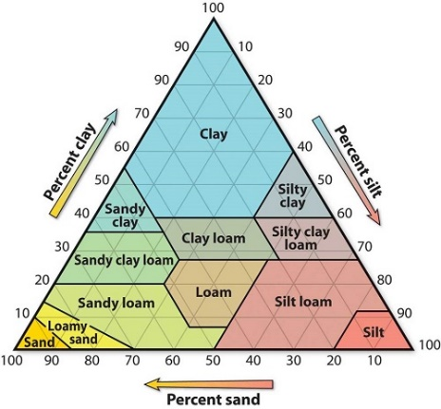
- Sand:
- Silt:
- Clay:

- Understand how to use the texture triangle

  - Soil Structure:
- Aggregate: mass or cluster of soil particles such as clod, crumb or granule.

- Structure: the combination or arrangement of soil particles into aggregates.

  - Soil Color:
- Indicator of different soil types
- Indicator of certain physical and chemical characteristics
- Due to humus content and chemical nature of the iron compounds present in the soil
- Time: Soil develops and changes over time

Soil affects Vegetation which affect Soil … and on and on

3 soil orders that are the primary soils in rangeland ecosystems:
- Mollisols:

- Aridisols:

- Entisols:

Soil Maps:
- Soil Series: a group of soils that are similar in texture and profile

- Soil Map Units: grouping of soils that occur together, often based on geomorphology

- Management Implications:

Ecological Sites
- Abiotic →
Vs
- Biotic →

- Specific physical characteristics: soils, climate, hydrology, geology, topography.
- Differ in its ability to produce distinctive kinds and amounts of vegetation.
- Respond similarly to management actions and natural disturbances.

Ecological Sites – Based on Soil
- Soil affects the type of plants that grow on the land.
- Therefore, soil maps usually form the basis for maps of ecological sites.
- Ecological Site Descriptions – can be found by starting with soil maps in the Web Soil Survey

Ecological Potential & Dynamics
