Guidelines for Setting “Proper” Stocking Rate
Four Grazing Mgmt Factors:
- Number of Animals (How Many?)
- Type of Animal (What?)
- Time of Grazing (When?)
- Duration or Length of Grazing (How Long?)
Carrying Capacity =

Stocking Rate =

Forage Demand of Animal
- Ruminants - Eat 2.5% of body weight/day in dry matter of forage.
  - Cattle, sheep, goats
  - Deer, elk, bighorn sheep, moose, etc.
- Hind-Gut Fermentors -Eat 3.0% of body weight/day in dry matter of forage.
  - Horses
  - Rabbits and rodents

Animal Unit Month (AUM) =

Proper Stocking Rate? from Rangeland Health Standpoint
- Proper stocking based on maintaining sufficient plant residue for:

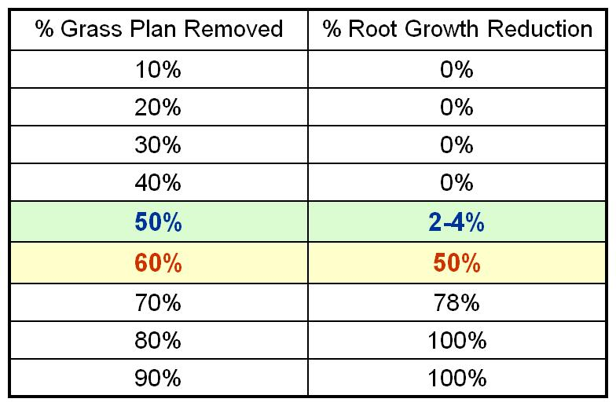

- Set stocking rate below carrying capacity

- Heavy use ≠ Overgrazing
- Overgrazing = repeated heavy grazing such that damage to the plant community occurs
- Overstocking = heavy grazing during a specific season such that high levels of utilization are observable.

- For Rangeland Health: Set Stocking Rates Below Carrying Capacity

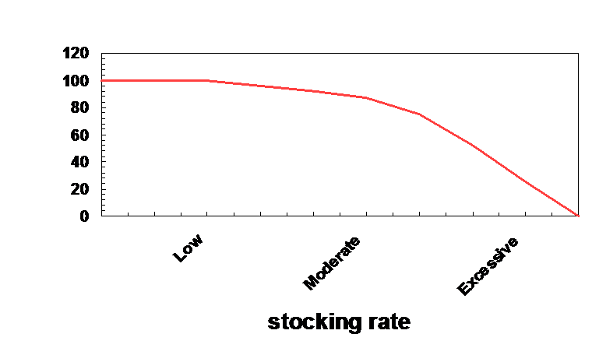
Proper stocking rate? From Livestock Production Standpoint
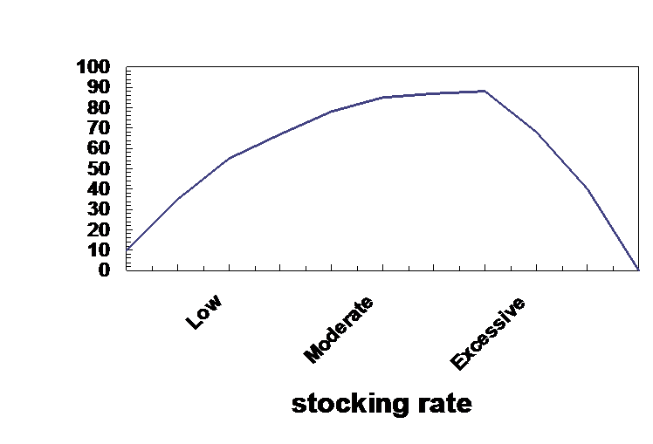

For Livestock Production: Set Stocking Rates At or Below Carrying Capacity
How do you set stocking rate?
Balance supply with demand - 4-step or Forage Demand Method
- Calculate usable forage
- Adjust for terrain, water, or other constraints
- Calculate forage demand of animals
- Calculate stocking rate

The forage demand method is used:
- When you have no stocking information from previous years
- To estimate carrying capacity in biological surveys or land appraisal
- When considering changes in kind or class of animals

Flexible vs Constant stocking:
- Establish stocking rate based on:
- Past experience
- Current situation
- Long-range weather forecast
- Financial goals
- Etc.
- Set a Stocking Rate and Then Monitor!

With this method stocking rate is determined by trial and error over years and then monitored by:
- Range Trend = changes in plant composition or rangeland health over time
- Grazing Principles
- Which animal -Animal Species & Class
- How may animals -Stocking Rate
- When to grazing or not graze -Grazing System

