Rangeland Succession
- Succession
  - The orderly change of plant communities over time.
  - The gradual replacement of one plant community by another through natural processes over time
    - Primary = From parent material
    - Secondary = With soil in place
- Primary Succession
  - Soil and plants evolve together
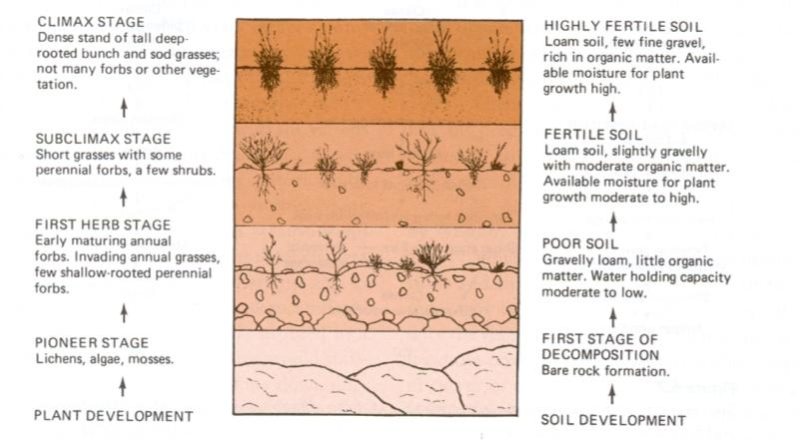
- Primary Succession
  - Begins in a place without any soil
    - Sides of volcanoes
    - Landslides
    - Flooding
  - Starts with the arrival of living things such as lichens that do not need soil to survive
    - Called PIONEER SPECIES
  - Soil starts to form as lichens and the forces of weather and erosion help break down rocks into smaller pieces
  - When lichens die, they decompose, adding small amounts of organic matter to the rock to make soil
- Secondary Succession
  - Begins in a place that already has soil and was once the home of living organisms
  - Occurs faster and has different pioneer species than primary succession
  - Example: after forest fires
    - Others?
- Basic idea of Succession
  - The simple plants die, adding more organic matter.
  - The soil layer thickens, and grasses, wildflowers, and other plants begin to grow (annuals & herbaceous).
  - These plants die, and they add more nutrients to the soil.
  - Shrubs and tress can then survive.
  - Insects, small birds, and mammals begin to inhabit.
** What was once bare rock now supports a variety of life.
** We manage forces that cause these changes.
- Forces of Ecosystem Change
  - Immigration and establishment of plants
  - Competition between plants
  - Site modification
    - Add organic matter
    - Change available moisture and nutrients
  - Stabilization
    - Reduced yearly variation in kind and amount of plants and animals.
- Climax Community
  - The end point of succession = Climax
  - A stable group of plants and animals that is the end result of the succession process
    - Trees in forests
    - Grasses in prairies
    - Cacti in deserts
    - Lichens and shrubs in the tundra
  - The end point depends on climate

