Plant Nutritive Value

Based on the most limiting nutrients on rangelands in the western U.S.
- Energy
  - Structural carbohydrates (e.g., cellulose)
  - Sugars & starch
  - Fats (to a limited degree, but important for birds and rodents).

- Nutrients –
  - Protein - Nitrogenous compounds
  - Phosphorus = generally most limiting mineral on rangelands
  - Vitamins = Carotene or Vitamin A

The 3 major factors determining nutritive value in plants:
- Cell structure: (Ration of Cell Wall to Contents)
- Degree of Lignifications
- Secondary Compounds or “Anti-quality” factors

Cell structure: (Wall:Contents)

Degree of Lignification
- Lignin - indigestible portions of cell walls that impregnates cellulose to form wood.

Secondary Compounds or “Anti-quality” factors
- Plants may contain compounds or toxins that reduce forage quality or adversely affect the herbivore

Comparative Nutritive Value of Plant Parts
- Fruits, seeds, root-crowns and flowers generally have higher levels of cell contents (cell solubles) and are therefore more nutritious than leaves or stems.
  - Seeds also contain significant levels of fats

- Leaves are more nutritious than stems. Why?
  - More cell contents
  - Less structural CHO's
- In shrubs, current seasons growth is generally more nutritious than old growth. Why?
  - A
- What is browse?
  - The portion of shrubs used for forage. Generally, leaves & current seasons twigs.
stem age they become LIGNIFIED
Maturation Effects on Nutritive Quality:
- Most range plants are highly nutritious when young. Even plants that are normally considered undesirable (such as cheatgrass) are nutritious when young.
- As plants mature nutritive value decreases.
  - Increased structural CHO's
  - Lignification
  - Increasing Stem:Leaf Ratio
  - Leaching of nutrients by rain in dormancy.
  - Leaching is when rain washes soluble nutrients out of the plant into the soil. Plants that
  - resist leaching due to dry climate, morphology, or range site are said to "cure" well.

Comparative Nutritive Value of Grasses, Forbs, and Shrubs
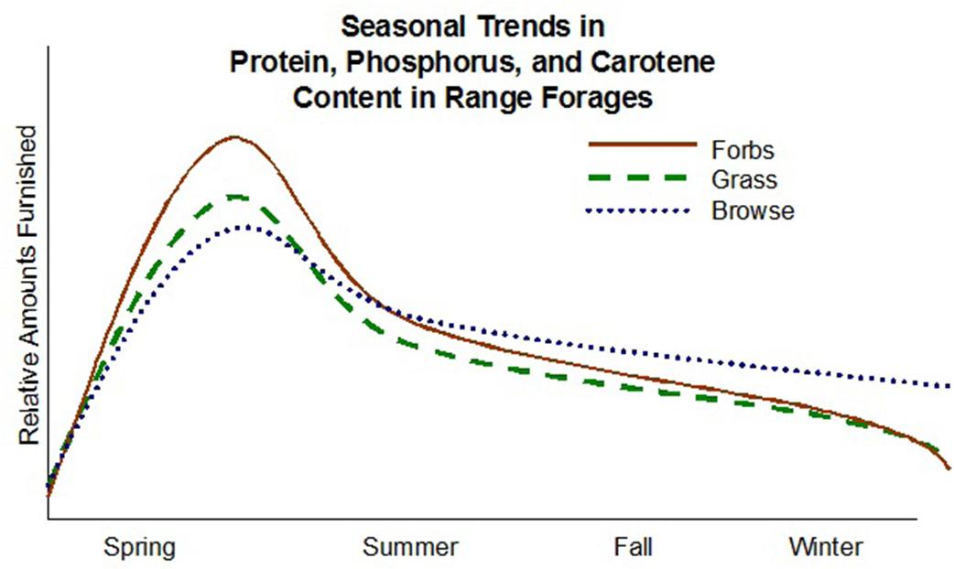
- During growing season - forbs are more nutritious than grasses (which are more nutritious than shrubs).

- This is because the cell wall of grasses is thicker than the cell wall of forbs.

- During dormant season - browse are important for nutrients.

C3 (Cool Season) vs C4 (Warm Season) Grasses
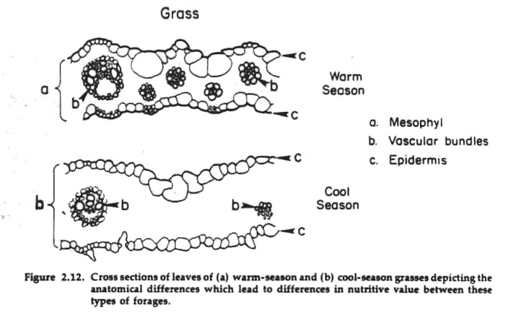

Comparative Nutritive Levels of Grasses, Forbs, and Shrubs
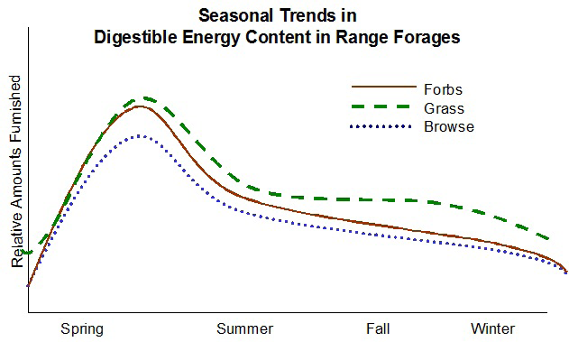
- During growing season - grasses, forbs, and shrubs all provide good amounts of energy

- During dormant season - grasses provide a stable source of energy.

Anti-quality Agents:
- Most common in shrubs and forbs.
- Rarely a problem in grasses
- Inhibitors - may cause illness but also inhibit digestion
  - React with dietary proteins to form complexes resistant to microbial degradation.
  - Inhibit digestion inhibiting microbial growth.
- Toxins - cause illness or death (i.e., alkaloids)

Recap:
- Forbs are important sources of protein and carotene during the growing season.
- Shrubs are important to maintain phosphorus and protein levels in winter (dormant season).
- Grasses are important sources of energy (structural CHO's) throughout the year.
- Forbs and shrubs may contain anti-quality agents which decrease their nutritive value.

