Grazing Animal Behavior
- Basis for Animal Behavior
  - What affects how animals behave:
    - Born with certain abilities:
      - Inherited abilities
      - Physical, Sensory & Physiological Abilities
    - Born knowing what to do:
      - Called “Instincts”
    - Learn how behave

- Inherited Abilities
  - Physical abilities affect what animals eat
    - Ability to eat cellulose
    - Capture and Consume Prey

- Select Correct Species
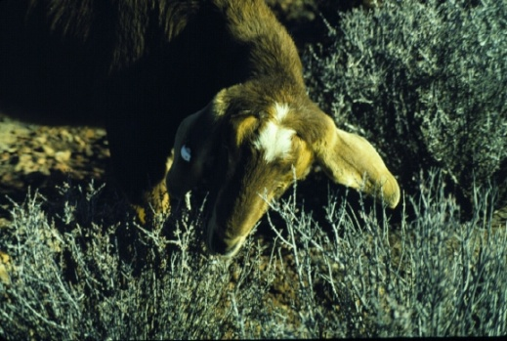
Concentrate Feeder (browse)

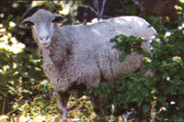
Intermediate Feeder (forbs)

Roughage Feeder (grass)

- Inherited Abilities
  - Physical abilities affect where animals eat

Select Correct Breed
Inherited Behaviors - Instincts
Mammals know how to find milk and stay close to mother.
Basic ideas of what is cover
& how to hide
Preference for salty foods
Preference for sweet…
not sure
Inherited Behavior - Instincts
Behavioral characteristics can be inherited
  - Example = Guard Dogs vs Herding Dogs
Basics of Animal Behavior
4 Basic Learning Paradigms
Young animals clearly learn what
to eat avoid from their mother
Learning from Mother
Early Life Experience is Influential
Preferences are formed
Early dietary experience
Goats - 6 weeks old
  - Experienced: raised on blackbrush range
  - Inexperienced: drylot fed alfalfa pellets
Weaned at 26 weeks
Week 28 - offered all goats blackbrush in pens
Early dietary experience
Animals must learn how to eat
Build Foraging Skills
Animals learn based on consequences
Skin Defense System:
Animals learn based on consequences
Gut Defense System:
Animals learn based on consequences
Conditioned Aversions
Conditioned Aversions
Terpenes in sagebrush limit intake of sagebrush
Animals learn based on consequences
Gut Defense System:
Animals learn based on consequences
Conditioned Preference
Energy Increases Palatability
Nutrient – Toxin Interactions
Nutrient - Toxin Interactions
Use of Sagebrush by Sheep
Creating Designer Livestock
Select animals that naturally possess the desired ingestive characteristics
Breed animals with these abilities
Prepare animals with prescribed dietary experiences
Offer animals nutritional or pharmaceutical resources to aid in digestion or detoxification
For More information:
www.behave.net

